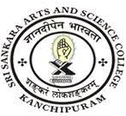
SRI SANKARA ARTS AND SCIENCE COLLEGE
(AUTONOMOUS)
ENATHUR

1.3.4 Details of Students Undertaking Field Work, Projects, Internships, Student Projects during the year 2021-22

Sl.no | Department | Link to Document
1 | MICROBIOLOGY | View Document
2 | BIOTECHNOLOGY | View Document
3 | BIOCHEMISTRY | View Document
4 | COMPUTER SCIENCE | View Document
5 | COMMERCE | View Document
6 | BUSINESS ADMINISTRATION | View Document
7 | PHYSICS | View Document

