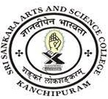
SRI SANKARA ARTS AND SCIENCE COLLEGE
(AUTONOMOUS)
ENATHUR

2.6.1 Programme Outcomes and Course Outcomes

Sl.no | Department | Link to Document
1 | Undergraduate Programmes | View File
2 | Postgraduate Programmes | View File

