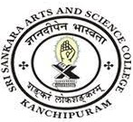
SRI SANKARA ARTS AND SCIENCE COLLEGE
(AUTONOMOUS)
ENATHUR

Details of subscriptions like e-journals, e-books, e-ShodhSindhu, Shodhganga membership

