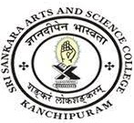
SRI SANKARA ARTS AND SCIENCE COLLEGE
(AUTONOMOUS)
ENATHUR

3.7.2 Details of functional MoUs with institutions of national, international importance, other universities, industries, corporate houses etc. during the year
Sl.no | Department | Link to Document
1 | Biotechnology | View Document
2 | Biochemistry | View Document
3 | Business Administration  MoU-1 | View Document
4 | Business Administration  MoU-2 | View Document
5 | Business Administration  MoU-3 | View Document
6 | Business Administration  MoU-4 | View Document
7 | Computer Science | View Document

