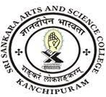
SRI SANKARA ARTS AND SCIENCE COLLEGE
(AUTONOMOUS)
ENATHUR

3.2.3 Teachers Recognized as Research Guides
Sl.no | Department | Link to Document
1 | Guideship Recognition Communication from Affiliating University | View File

