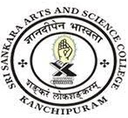
SRI SANKARA ARTS AND SCIENCE COLLEGE
(AUTONOMOUS)
ENATHUR

5.1.1 Students benefited by scholarships and freeships provided by the Government (2021-2022)
Sl.no | Particulars | Related Document
1 | Scholarships provided by the Government | View Document

