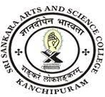
SRI SANKARA ARTS AND SCIENCE COLLEGE
(AUTONOMOUS)
ENATHUR

3.3.2 Workshops, Seminars on Research Methodology, IPR, Entrepreneurship and Skill Development
Sl.no | Department | Link to Document
1 | Report of EDC Events | View File

