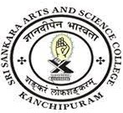
SRI SANKARA ARTS AND SCIENCE COLLEGE
(AUTONOMOUS)
ENATHUR

3.7.1 Details of collaborative activities for Research, Faculty Exchange, Student Exchange, Internship, on-the-job training, Project work during the year 2021-22
Sl.no | Department | Link to Document
1 | Biotechnology | View Document

