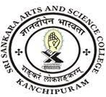
SRI SANKARA ARTS AND SCIENCE COLLEGE
(AUTONOMOUS)
ENATHUR

1.1.2 Details of Programmes where Syllabus Revision was Carried Out during the Year 2021-22
Sl.no | Department | Link to Change of Syllabus | Link to Minutes of BoS Meeting Approving the Change of Syllabus
1 | MATHEMATICS | MathSyllabus.pdf | MathBoS.pdf

